**Insurance fraud analysis by Tableau**

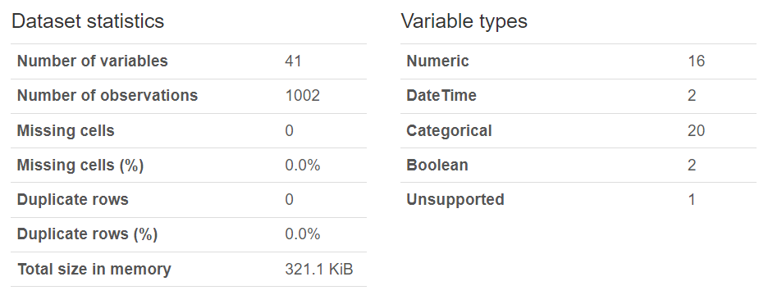

**Discrepancies found in the data :**

The policy number should be 6 digits, but there are 2 numbers which has 5 digits.

In the insured relationship column, it is mentioned as not in family.

In some cases the policy bind date is much before than the car manufacturing year.

In some cases where authorities contacted are “Police” , there the police report availability is “No”.

In cases where number of bodily injuries is “0” there the injury claim is mentioned.

**Clients suggestions**

Use images, logo, switches/navigation, use good colors.

Use charts on tool tips

Change the data type to Boolean- for performance optimization

Hide all the unused columns

Action filters instead of quick filters

Use context filters

Use workbook optimizer

**Changes made in the data set.**

1. Recreated the “month as customer” column by using DATEDIFF function in excel taking the “policy bind date” and “incident date”
2. There should not be “capital gain” and capital loss” at the same time. For all the cases where capital loss is there the capital gain value is made “0”
3. There was one negative value present in “umbrella limit” column which was turned into positive.
4. For the cases where “authorities contacted” was police and the “police report available” was “NO” , it was changed to “YES”
5. In the “Bodily injury” column where the number of injury was “0” and for them the “injury claim” column was not showing “0”. we changed the “Bodily injury” value to 1 and 2 alternatively using the function =IF(MOD(ROW(),2)=0,1,2)
6. There are cases where “property damage” is “NO” but the “property claim” column is not showing “0” , we assume these are fraud cases and leave it as it is.

**Challenges**

1.While creating a drill down pie chart , I had put the no of claims in size card hence the size of the charts were increasing simultaneously, after removing them from the size card, it worked.

1. While creating sun burst chart using map layer method I was facing a challenge to change the size of respective pie charts. What I was doing , that I was directly dragging the insured education level to colors and details and then trying to chane the size, but I first changed the size and then dragged them into their respective places and it worked.
2. When I dragged the drill down bar chart sheet to dashboard, the set actions were not working in the dashboard but it was working in the sheet. So I enabled the source sheet to “All” options in the dashboard action option and then it worked.

Learning:

1. Data cleaning and manipulating by proper analysis.
2. Creating custom charts, Sunburst, Drill down bar graphs, pie charts, tool tip charts, navigation
3. Tableau server, performance optimization, checking on load stats, custom view, creating subscription and alerts,